Khmer Angkor Keyboard

Contents

Overview 2

Khmer Angkor Keyboard Layouts 2

Desktop –Windows/macOS 2

Touch –Android/iOS 3

Khmer Character Categories and Their Keystroke 4

Consonants 4

Dependent Vowels 5

Independent Vowels 5

Diacritics 5

Native Punctuations 6

Latin Punctuations 6

Currencies 6

Khmer Numerals 6

Divination Lore 6

Khmer Lunar Dates 7

Deprecated characters 7

Typing in Khmer 8

Joiners and Spaces 8

Constraints 8

Reorder 8

Rotation 8

# Overview

This documentation is adapted from two sources: ‘How to Type Khmer Unicode’ and ‘the Unicode Standard, Version 10.0.0’. Customizations have been made by the Keyman team.

# Khmer Angkor Keyboard Layouts

## Desktop –Windows/macOS

SHIFT key off

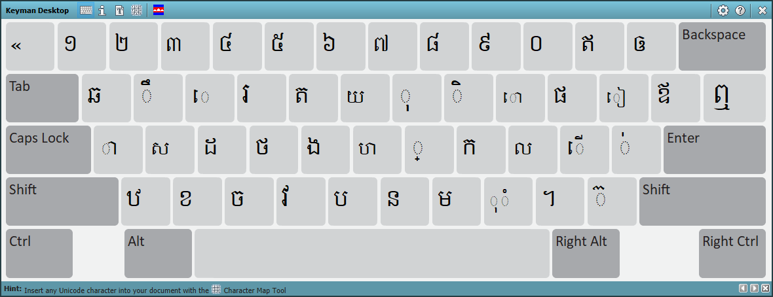

SHIFT key on

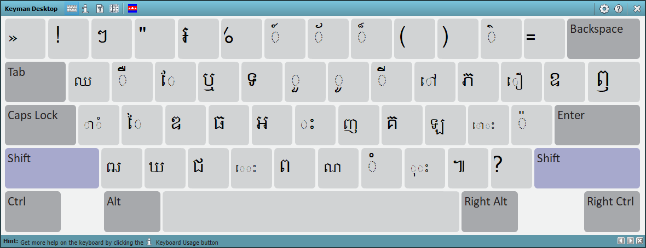

Right ALT key on (now Ctrl Alt)

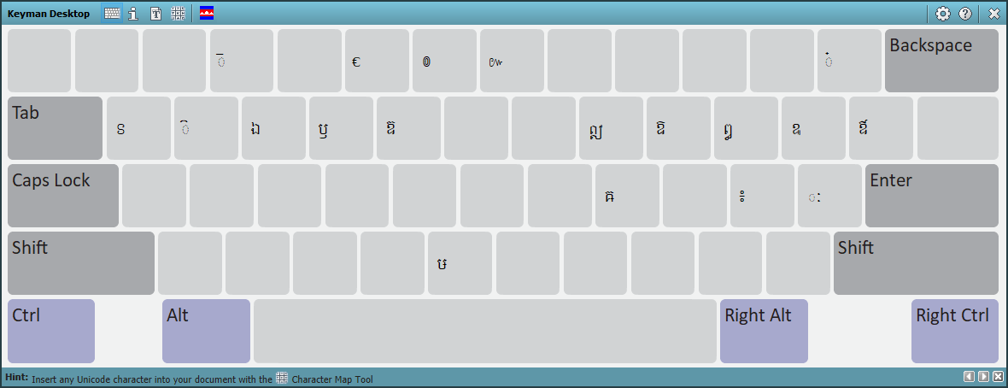

Ctrl Alt Shift key on

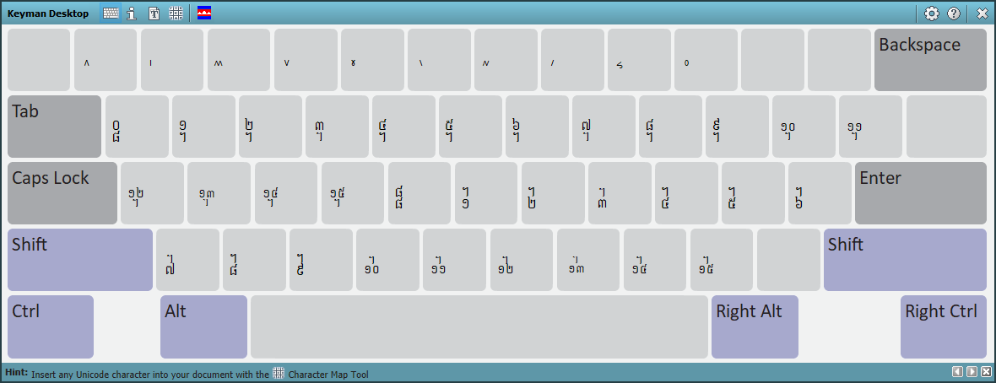

## Touch –Android/iOS

Default layout

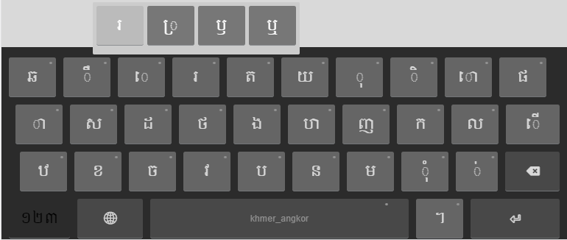

Numeric layout

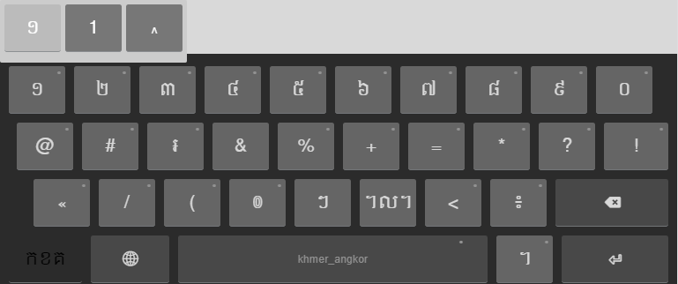

# Khmer Character Categories and Their Keystroke

Each character has a corresponding keystroke under it.

## Consonants

|  |  |  |  |  |
| --- | --- | --- | --- | --- |
| **Consonant** | **Keystroke** |  | **Consonant** | **Keystroke** |
| ក | K | ប | B |
| ខ | X | ផ | P |
| គ | Shift K | ព | Shift B |
| ឃ | Shift X | ភ | Shift P |
| ង | G | ម | M |
| ច | C | យ | Y |
| ឆ | Q | រ | R |
| ជ | Shift C | ល | L |
| ឈ | Shift Q | វ | V |
| ញ | Shift J | ស | S |
| ដ | D | ហ | H |
| ឋ | Z | ឡ | L |
| ឌ | Shift D | អ | Shift G |
| ឍ | Shift Z |  |  |
| ណ | Shift N |  |  |
| ត | T |  |  |
| ថ | F |  |  |
| ទ | Shift T |  |  |
| ធ | Shift F |  |  |
| ន | N |  |  |

## Dependent Vowels

|  |  |  |  |  |
| --- | --- | --- | --- | --- |
| **Dependent Vowel** | **Keystroke** |  | **Dependent Vowel** | **Keystroke** |
| ា | A | ែ | Shift E |
| ិ | I | ៃ | Shift S |
| ី | Shift I | ោ | O |
| ឹ | W | ៅ | Shift O |
| ឺ | Shift W | ុំ | , |
| ុ | O | ំ | Shift M |
| ូ | Shift O | ាំ | Shift A |
| ួ | Shift Y | ះ | Shift H |
| ើ | ; | ុះ | Shift , |
| ឿ | Shift [ | េះ | Shift V |
| ៀ | [ | ោះ | Shift ; |
| េ | E | ៈ[1] | Ctrl Alt ’ |

## Independent Vowels

|  |  |  |  |  |
| --- | --- | --- | --- | --- |
| **Independent Vowel** | **Keystroke** |  | **Independent Vowel** | **Keystroke** |
| ឥ | - | ឭ | Shift \ |
| ឦ | Ctrl Alt I | ឮ | \ |
| ឧ | Shift ] | ឯ | Ctrl Alt E |
| ឩ | Ctrl Alt [ | ឰ | Ctrl Alt P |
| ឪ | ] | ឱ | Ctrl Alt O |
| ឫ | Ctrl Alt R | ឲ | = |
| ឬ | Shift R | ឳ | Ctrl Alt ] |

## Diacritics

|  |  |  |  |  |
| --- | --- | --- | --- | --- |
| **Diacritics** | **Keystroke** |  | **Diacritics** | **Keystroke** |
| ៉ | Shift ’ | ៏ | Shift 8 |
| ៊ | / | ័ | Shift 7 |
| ់ | ’ | ៎ | Ctrl Alt = |
| ៌ | Shift - | ៑ | Ctrl Alt 3 |
| ៍ | Shift 6 | ៓ | Ctrl Alt M |

## Native Punctuations

|  |  |  |  |  |
| --- | --- | --- | --- | --- |
| **Native Punct.** | **Keystroke** |  | **Native Punct.** | **Keystroke** |
| ។ | . | ៘ | Ctrl Alt L |
| ៕ | Shift . | ៙ | Ctrl Alt 6 |
| ៖ | Ctrl Alt ; | ៚ | Ctrl Alt 7 |
| ៗ | Shift 2 |  |  |

## Latin Punctuations

|  |  |
| --- | --- |
| **Latin Punct.** | **Keystroke** |
| ! | Shift 1 |
| ? | Shift ? |
| “ | Shift 3 |
| . | Ctrl Alt . |
| , | Ctrl Alt , |
| « | ` |
| » | Shift ` |

## Currencies

|  |  |
| --- | --- |
| ៛ | Shift 4 |

## Khmer Numerals

|  |  |  |  |  |  |  |  |  |  |  |
| --- | --- | --- | --- | --- | --- | --- | --- | --- | --- | --- |
| **Khmer Numeral** | ១ | ២ | ៣ | ៤ | ៥ | ៦ | ៧ | ៨ | ៩ | ០ |
| **Keystroke** | 1 | 2 | 3 | 4 | 5 | 6 | 7 | 8 | 9 | 0 |

## Divination Lore

|  |  |  |  |  |
| --- | --- | --- | --- | --- |
| Divination Lore | Keystroke |  | Divination Lore | Keystroke |
| ៱ | Ctrl Alt Shift 1 | ៶ | Ctrl Alt Shift 6 |
| ៲ | Ctrl Alt Shift 2 | ៷ | Ctrl Alt Shift 7 |
| ៳ | Ctrl Alt Shift 3 | ៸ | Ctrl Alt Shift 8 |
| ៴ | Ctrl Alt Shift 4 | ៹ | Ctrl Alt Shift 9 |
| ៵ | Ctrl Alt Shift 5 | ៰ | Ctrl Alt Shift 0 |

## Khmer Lunar Dates

|  |  |  |  |  |
| --- | --- | --- | --- | --- |
| Khmer Lunar Date | Keystroke |  | Khmer Lunar Date | Keystroke |
| ᧠ | Ctrl Alt Shift Q | ᧰ | Ctrl Alt Shift G |
| ᧡ | Ctrl Alt Shift W | ᧱ | Ctrl Alt Shift H |
| ᧢ | Ctrl Alt Shift E | ᧲ | Ctrl Alt Shift J |
| ᧣ | Ctrl Alt Shift R | ᧳ | Ctrl Alt Shift K |
| ᧤ | Ctrl Alt Shift T | ᧴ | Ctrl Alt Shift L |
| ᧥ | Ctrl Alt Shift Y | ᧵ | Ctrl Alt Shift ; |
| ᧦ | Ctrl Alt Shift U |  | ᧶ | Ctrl Alt Shift ’ |
| ᧧ | Ctrl Alt Shift I |  | ᧷ | Ctrl Alt Shift Z |
| ᧨ | Ctrl Alt Shift O |  | ᧸ | Ctrl Alt Shift X |
| ᧩ | Ctrl Alt Shift P |  | ᧹ | Ctrl Alt Shift C |
| ᧪ | Ctrl Alt Shift [ |  | ᧺ | Ctrl Alt Shift V |
| ᧫ | Ctrl Alt Shift ] |  | ᧻ | Ctrl Alt Shift B |
| ᧬ | Ctrl Alt Shift A |  | ᧼ | Ctrl Alt Shift N |
| ᧭ | Ctrl Alt Shift S |  | ᧽ | Ctrl Alt Shift M |
| ᧮ | Ctrl Alt Shift D |  | ᧾ | Ctrl Alt Shift , |
| ᧯ | Ctrl Alt Shift F |  | ᧿ | Ctrl Alt Shift . |

## Deprecated characters

|  |  |
| --- | --- |
| Deprecated Character | Keystroke |
| ឝ | Ctrl Alt K |
| ឞ | Ctrl Alt B |
| ឨ | Ctrl Alt T |
| ៜ | Ctrl Alt Q |
| ៝ | Ctrl Alt W |
| ៑ | Ctrl Alt 3 |
| ៓ | Ctrl Alt M |

# Typing in Khmer

Khmer Angkor keyboard adopted the key arrangement from that of NiDA keyboard. More functionalities have been added to it to assist in typing. A well-formed word will be produced regardless of however the user may press. Please note that only issues identified have been covered. To install the keyboard, please follow the instruction [here](https://help.keyman.com/products/desktop/9.0/docs/start_download-install_keyboard.php).

You can simply use Khmer Angkor as you would for any NiDA based keyboard.

## Joiners and Spaces

|  |  |  |
| --- | --- | --- |
| **Key name** | **Code Point** | **Keystroke** |
| Zero-width non-joiner | U+200C | Ctrl + Alt + 1 |
| Zero-width joiner | U+200D | Ctrl + Alt + ‘ |
| Zero-width space | U+200B | Spacebar |
| White space | U+0020 | Shift + Spacebar |
| No break space | U+00A0 | Ctrl + Alt + Spacebar |

## Constraints

## Reorder

## Rotation

1. It is actually not a vowel, but it behaves like one.